Exponential Functions:

- Definition

2. Graphs

Practice 1.

Take photos/screenshots of your answers and submit them to Canvas under Assignment_Feb_25.

Note: In the long run, exponential growth is faster than any polynomial/power
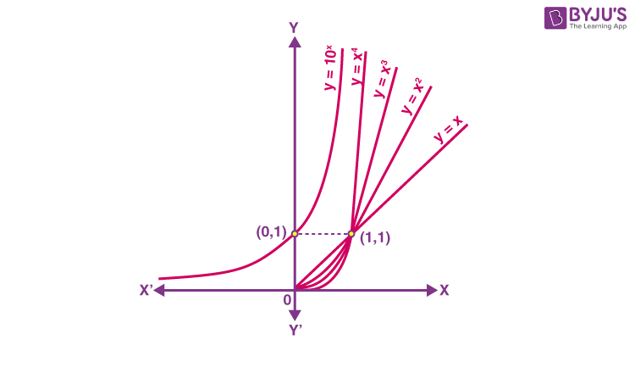
3. Paper folding Example

Fold a standard sheet of paper 42 times. How thick would it be?

Every time we fold the paper, the thickness of the paper is doubled. This is exponential growth with base 2.

Question: How thick would it be?
Answer: The paper would be thicker than the distance between the Earth and the Moon.

Why?

We need to know how thick a standard sheet of paper is? 0.004 inches

If we fold the paper x times, the thickness of the paper is:

The thickness when x = 42, the thickness is

= 17592186044.4 (inches) = 277, 654 (miles)

The distance between the Earth and the Moon is 238,855 (miles).

4. Two forms: base e and regular base, b

Practice 2:
- Convert to base e form
- Convert to the standard form

Take photos/screenshots of your answers and submit them to Canvas under Assignment_Feb_25.

4. Solving Exponential Equations.

Log operator/function

In general,

Properties of Log

How to solve exponential equations using log:

Solving steps:
- Isolate the base
- Take the log of both sides
- Use logarithmic properties to simplify the expression and solve for x
- Round all answers to 4 decimal places

Example:
Solve:

Practice 3

Solve for x

Take photos/screenshots of your answer and submit it to Canvas (Assignment_Feb_25).

